**Vital Meeting (12/16/15)**

**Required changes:**

1. Today note first.

Done.

1. Navigation section stable (not scrollable).

Postponed since navigation is still in progress.

1. Add delete button for Tx Treatment

Done.

1. Add delete button for modalities/procedures/….

Done (modality only, not sure if others shoud be lists?).

1. Move Assessment/Plan tab into Sub/Obj tab.

Done.

1. Change Sub/Obj tab name to “Note Datails”

Done.

1. Add patient information section to navigation bar (on top):
   1. Patient Name (first, last)
   2. Insurance name
   3. DX: (diagnosis)
   4. Date (already there but don’t set a default to today)
   5. Visit #
   6. Authorized visits #
   7. Authorized visits (from/to)
   8. Total Tx Time (how is this calculated?)
   9. Total Min Timed Code

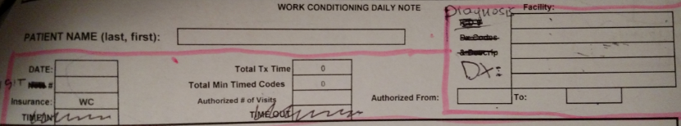

Done.

1. Add Vital Signs section right above Subjective (show/hide)

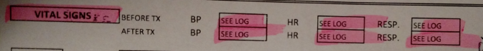

Done.

1. Add “Need authorization” checkbox at “Edit Patient” screen.

Done.

1. Check if visit is authorized based on # of visits left when creating Note. Show warning if not authorized but still allow to save Note.

Partially done (need to include date range in authorization check).

1. Remove “v” from buttons in modalities/procedures.

Done.

1. Remove “WC addl” button from Procedures.

Done.

1. Change “WC2 hours” button to “WC”.

Done.

1. Add special section when clicking “WC” button. “WC2hours” and “WC addl” codes will be generated during report creation based on number of minutes entered for entire WC). WC2hours - up to 120 minutes. Multiple WC addl – for every additional minute up to 60mins.

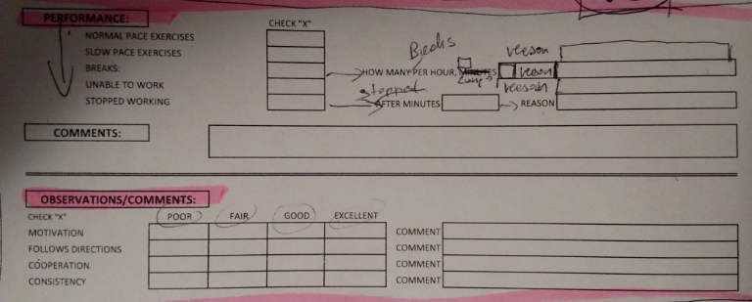

I assume WC section will be each TX Area (just like other modalities/procedures), correct?

Done.